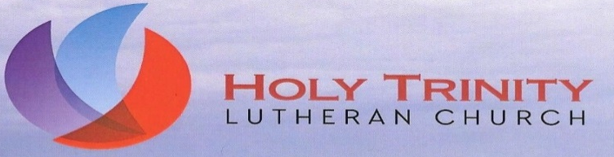

David M. Doane, Pastor ddoane@htlcweb.org
Carol Letcher, Choir Director & Organist
Sue Lambert, Parish Administrator office@htlcweb.org

Wednesday, June 10, 2020
Dear Sisters and Brothers in Christ,
Greetings in the Name of our Lord and Savior Jesus Christ.
I want to keep you informed about our current status and our expectations for the future. You know that at the May 2020 Church Council meeting, a task force was formed to study issues concerning a return to in-person worship and to make recommendations to Council. The taskforce completed their work and submitted their report at the June 2020 Council Meeting. The task force members were Nita Cunningham (Council President) Kevin Letcher (Council Vice President and member of the Evangelism Team), Sue Lambert (Parish Assistant and worship committee member), Wayne Russell (Property Committee), Deb Pohlenz (Nurse) and Lisa Strauser (Custodian). A big thank you goes to these six people for their faithful, caring work.
Council adopted the recommendations of the task force with only one change in the cost estimates of projects presented in preparation for reopening. The biggest question is when. Holy Trinity will continue to do Live Stream worship only through June. At the end of June, a re-evaluation of COVID-19 new infection data will be reviewed and a decision made on whether to extend Live Stream Worship only or to re-introduce in-person worship within certain boundaries. The hope is to return to in-person worship sometime in July.
I know you are anxious to come back to church. So am I. I miss all of you and look forward to the day we can be personally and physically together again. But the well-being and safety of our members comes first. I would not want anyone to become infected with COVID-19 because we began in-person worship too soon. I know you are aware that other congregations around us are reopening. What you may not know is just as many congregations around us are delaying a return to in-person worship and for the same reasons as us. Our primary concern is for the health and well-being of our members.
I know it is hard, but I ask for your continued patience and prayers. You have been so good and so faithful. We will continue our Live Stream Worship at 9:30 AM Sunday morning. Though we still have some issues, I think we are getting better with the technology, especially since we started from scratch. I am happy to tell you we were awarded a grant from the Center for Congregations in Indianapolis for the purchase of upgraded technology which I think will make a big difference. We are at work trying to purchase the components.

Some of you have sent pictures of your “in-home altar” that you use on Sunday morning. I enjoyed seeing them. If you made one for your house please send me a picture. If you have not made one, consider making it. It does not have to be complicated. A candle, a small plate, a flower for decoration works just fine. Use your imagination. And send me a picture and I will share it with everyone, with permission of course.
Part of me writes this letter with a heavy heart because I want to tell you we will return to in-person worship right away. Another part of me is so thankful for your continued, generous support of Holy Trinity. I am so grateful to serve a faithful, loving congregation. Thank you. So, there is still another part of me that gives thanks to God for blessing us even in this time of pandemic.
Blessings to all of you. Keep the faith. Pray for one another. Stay in touch with me and each other. Trust God to protect and provide. Be safe and be will.
Cindy adds her greetings and prayers.

In Christ,

Pastor David

